The CPS Standard Operating Procedures (SOP) is a centralised online platform designed to encourage collaborative learning, sharing knowledge and best practices within Digital Information Directorate (DID).

This user guide has been created to assist users to update and maintain the CPS SOP. The guide has broken down into the following sections.

Contents

How to sign in 3

How to create a new page 3

How to update text 13

How to embed a document in a page (PowerPoint example) 20

Admins/Owners 27

Granting new users “Write” permission 27

Admins reviewing changes/Pull requests 29

Inviting a new user to the CPS Digital and Innovation organisation 33

Summary 34

Useful links 35

How to sign in**:**

If you wish to edit the Standard Operating Procedures (SOP) you must follow 2 steps:

**Step 1** – You must have a GitHub account. To create a GitHub account you can click here [Join GitHub · GitHub](https://github.com/signup?ref_cta=Sign+up&ref_loc=header+logged+out&ref_page=%2F%3Corg-login%3E&source=header) and create an account using **ONLY** your CPS email address.

**Step 2 –** You can click here <https://github.com/cps-innovation> to enter the CPS Digital and Innovation page and contact the Owner … and send them your GitHub username so they can add you to the CPS innovation GitHub organisation and grant you “Write” access.

**Step 3 -** Once you have requested to be added to the GitHub organisation, you will receive an email stating you have been invited to join the organisation. To join, click the “Join @CPS-innovation” button on the email which will direct you to the CPS innovation GitHub organisation home page.

How to create a new page**:**

To create a new page, visit the [GitHub repository](https://github.com/CPS-Innovation/digital-sop/tree/main/docs) and navigate to the folder where you wish to create the new page. For example, the CPS Digital and Innovation **“digital-sop”:**

A screenshot of the CPS Digital and Innovation homepage on GitHub with an arrow pointing to the "digital-sop" tab.

Once you have entered this page, click into the **“docs”** folder and select the sub folder you where you wish to create a page.

**\*Note\*** *Everything within the “docs” folder mirrors the page/navigation structure of the website.*

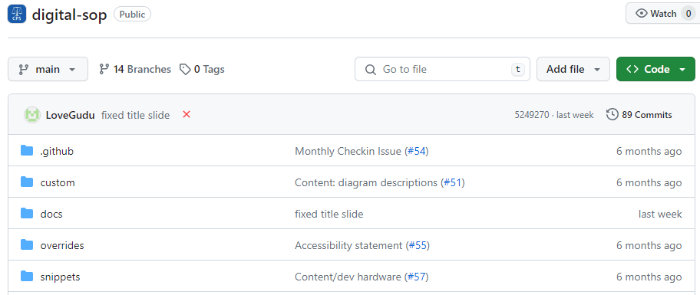

1. Click **"Add file".**

Once you are in the correct folder, select the **“Add file”** button on the top right of the page and then **“Create a new file”.**

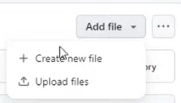

1. Give your new file a name, ensuring it follows the formatting standards, for example:
   * All lower case.
   * Hyphen separated words.
   * Ends with .md.
   * E.g. my-new-doc.md.

\***NOTE\*** *If you would like to create a new folder to put the document inside, put the folder name first then a forward slash (/) then the document name. For example – digital-sop/docs/strategy/newfolder/cultural-charter.md. Any new folder you do create, must have an “index.md” file inside of it. The “index.md” document is the home page which is displayed on the SOP web page. Any additional folders within a folder is what is displayed on the left navigation panel on the SOP web page.*

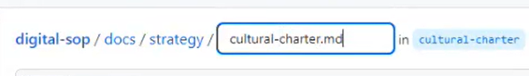

1. Add content to the new file, for guidance on formatting see the [Markdown Guide](https://www.markdownguide.org/cheat-sheet/). For example, adding a title (If you wish to add headings you must add the correct number of hashes with a space between the hash and the first letter of the text: Level one heading is a single hash (#) – Title # ABC.

Level two heading is two hashes (##) – Subheading ## ABC.

You must also ensure there is a line between each sentence/paragraph.

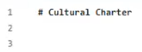

1. Once you have made your alterations, click **"Commit changes..."** which is located at the top right of the page.

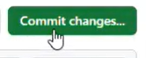

1. In the following dialog, describe your changes, select **"Create a new branch"**.

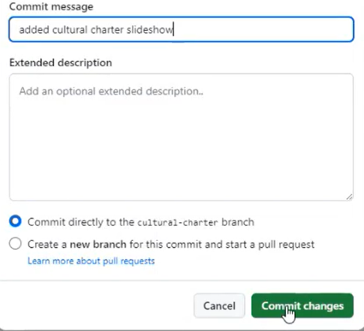

You can then give this branch a name. (Do not include spaces, if you require a space use the Hyphen (-) symbol.

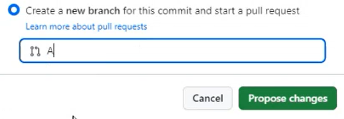

1. Once you are happy click **"Propose changes"** and you will be brought to a page where you will need to fill out the form details. You fill this out by replacing the text in the “Describe your changes” section for example remove the “<Describe your Changes>” and replace with what action you have taken.

You can then answer the other questions by creating a new line underneath each question, for example:

Once you have filled in the form details, you can click the “Create pull request” button.

This will then bring you to a checklist which you **MUST** complete this includes the “Why? What? How?” questions and the tick boxes.

If you wish to make multiple changes to new files or create/edit new files within the same change proposal, you need to click into the name of the branch you created from the “Pull requests” screen, for example:

This will take you through to a page which shows you the state of the repository after the last change that you made. You must ensure the drop-down box in the top left of the screen is displaying the name of your branch and not “main” as this is the actual site, for example:

You can then carry on making more changes as per the process above.

You should then notify another person with access to the GitHub organisation who will review your changes, possibly suggesting alterations. Once your changes have been reviewed and merged, it will take up to three minutes for the changes to reflect on the live website. You can do this by clicking “Reviewers” where you can then select which admin you want to review your changes.

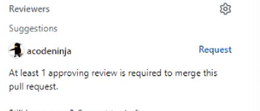

Once the admin has reviewed and approved your changes, you can go to the “Pull Requests” screen and select the request you created. In the “Conversations” tab it will display a green tick next to the “Reviewers” box which means the admin has reviewed and approved your work.

You can also see any comments the admin has made after reviewing your changes.

On this page, if you scroll down you will also see a list of changes that you made. If you see an Orange circle, this means there are checks being made in the background. These checks have to pass in order for the changes to be published.

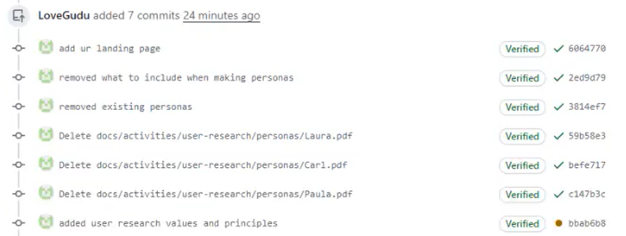

Once the checks are complete. The Orange circle will turn to a green tick.

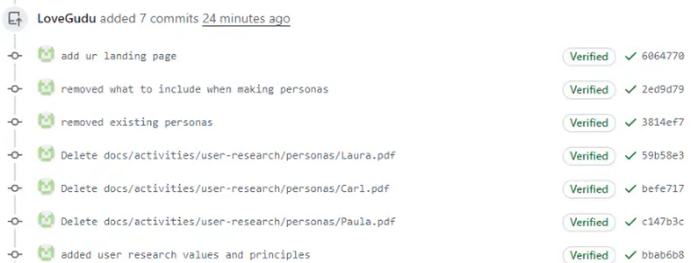

Once you have checked the changes are complete. Scroll to the bottom of the page. Once the admin has approved your changes and the above tests have passed you can then click “Squash and Merge”. Then “Confirm “Squash and Merge”.

How to update text**: From minute 22 to minute 39**

If you wish to edit the SOP ( ) you must got to **“digital-sop”**.

Once you have entered this page, click into the **“docs”** folder and select the sub folder you wish to edit.



**\*Note\*** *Everything within the “docs” folder mirrors the page/navigation structure of the website.*

*If you are unable to find the file that you wish to change, you can go into the website and navigate to the page you wish to edit and click the “edit” button in the top right corner of the page.*

For example if you wanted to edit the ‘personas’ page:

Enter the **“docs”** folder. Click **“activities”** and **“user-research”**. Then click **“personas”** , **“index.md”**.This will bring you to the ‘personas’ preview page.

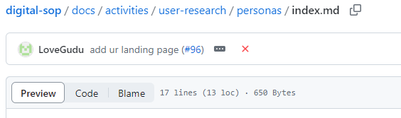

To edit, click the **“Edit”** (pencil icon’) in the top right of the page. You can then remove or add information where necessary.

A screenshot of the edit button with an arrow pointing to it. 

***\*You must ensure a blank line is placed after each paragpraph to keep the paragraphs seperated.\****

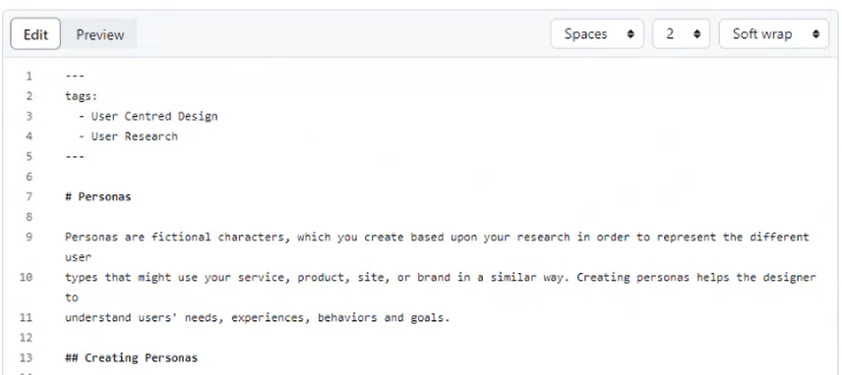

Once you are happy with your edits, click **“Commit changes”**.



In the pop up box, change the **“Commit message”** to what the specific action you took whilst editing the page (this is extremely important as this is a summary for an audit trail entry).

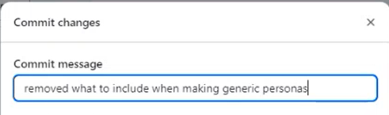

Ensure the tick box is selected to the branch you created/was already created before you edited the page, rather than creating a new branch. For example, **“Commit directly to the adding-ur-landing-page-branch”** then click **“Commit changes”**.

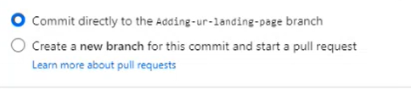

 Then you can click **“Commit changes”**.

A screenshot of the "Commit changes" button.

**\*TIP* *If you would like to add bullet points to your text, replace the circle bullet point with the hyphen (-) symbol and a space before the text. ‘- abc’ Please see “***[***Kitchen Sink***](https://github.com/CPS-Innovation/digital-sop/blob/524927091af4e83eed367e86a9192723d5e67df9/docs/activities/documentation/kitchen-sink.md#L1)***” for guidance and examples.***

***If you wish to add headings, you must add the correct number of hashes with a space between the hash and the first letter of the text:***

***Level one heading is a single hash (#) – Title # ABC***

***Level two heading is two hashes (##) – Subheading ## ABC***

Once you have made your edits/changes. Click on **“Pull requests”** at the top of the page to confirm the changes are ready to go in.



Then select the change request you created, for example **“add ur landing page”**.

You can scroll to the bottom of the page to review the changes you have made. You can also click the **“files changed”** tab at the top of the page which will give you a summary of the changes to the website.

A screenshot of the top of the page panel with an arrow pointing to the "Files changed" button. 

The website text will be displayed. The text that is highlighted in green is the text that has been added. The text that is highlighted in red is the text that has been removed.

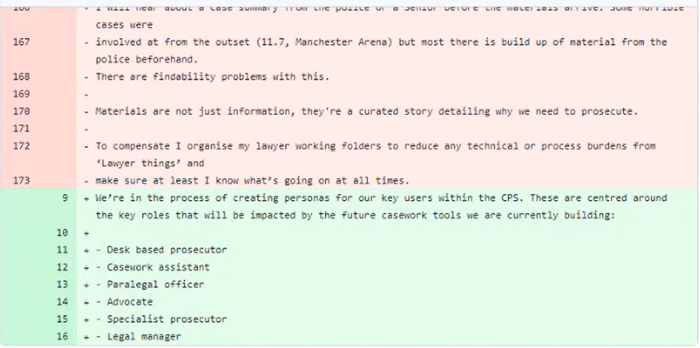

Once you have checked your changes, go back to the **“Conversation”** tab.

A screenshot of panel at the top of the page with an arrow pointing to the "Conversations" button. 

You will need to request for your changes to be reviewed by clicking “Reviewers”, this will then bring up a search box that allows you to type in a person or a team name who is part of the repository who can then review your work.



Once the admin has reviewed and approved your changes, you can go to the “Pull Requests” screen and select the request you created. In the “Conversations” tab it will display a green tick next to the “Reviewers” box which means the admin has reviewed and approved your work.

You can also see any comments the admin has made after reviewing your changes.

On this page, if you scroll down you will also see a list of changes that you made. If you see an Orange circle, this means there are checks being made in the background. These checks have to pass in order for the changes to be published.



Once the checks are complete. The Orange circle will turn to a green tick.



Once you have checked the changes are complete. Scroll to the bottom of the page. Once the admin has approved your changes and the above tests have passed you can then click “Squash and Merge”. Then “Confirm “Squash and Merge”.

After this, click the **“Actions”** tab at the top of the page.



Then click the second **“add ur landing page”** box which says **“Publish”** at the bottom.

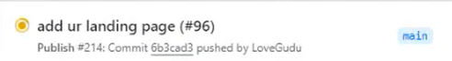

Once you have clicked this, wait a few seconds (up to 60 seconds for the build & 60 seconds for the deploy) as the website “build” is taking place.

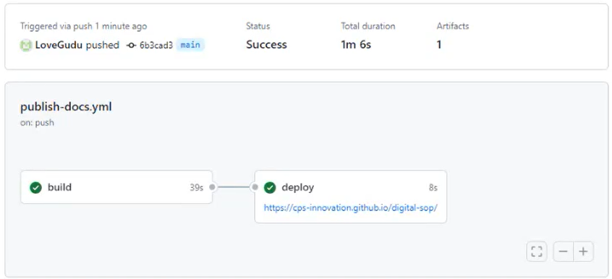

Once the build/deploy is complete, you can then go back to the website and your changes will be live.

How to embed a document in a page (PowerPoint example)**: 1 hour to 1 hour 17 minutes – Last few minutes explains how you can edit page through shortcut.**

If you wish to embed a PowerPoint slideshow in a page, you must have the document saved in your files and export the document in an SVG format (Save a copy – Select **“Scalable Vector Graphics Format”).** Once the document is saved in this format. You can begin the embedding process.

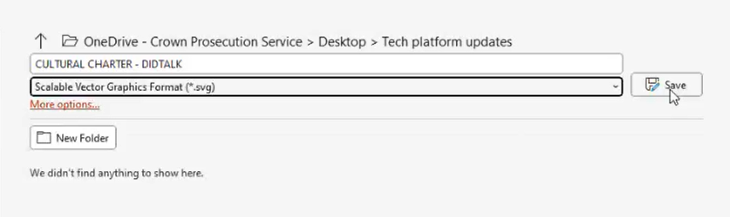

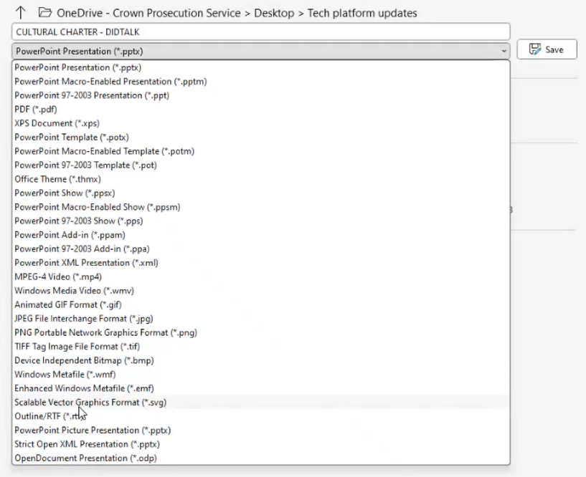

Once you have selected the correct format, click **“Save”** and save **“All slides”.**

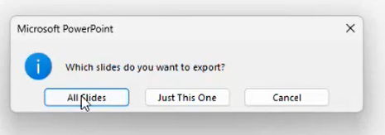

You can then enter the folder and page where you wish to embed the document. For example, enter **“digital-sop”**.

A screenshot of the CPS Digital and Innovation homepage on GitHub with an arrow pointing to the "digital-sop" tab.


Once you have entered this page, click into the **“docs”** folder and select the sub folder you wish to edit.



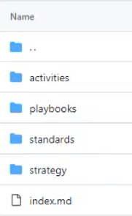

Once you are in the correct folder, select the **“Add file”** button on the top right of the page and then **“Create a new file”**.



You can then name your file at the top of the page (Please note the name must include **“.md”** at the end otherwise it will not appear on the website), for example:



You can then add your title heading by using the single hash (#) for level one headings, for example:

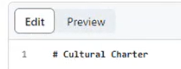

Once the title has been added, always add a blank line in between any text:



To begin embedding in a document (in this case a PowerPoint presentation), on the blank line (number 3) enter three back ticks (```) these are located next to the number 1 key on your keyboard.

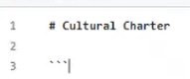

Then do two new lines leaving the fourth line blank. On the fifth line, enter another three back ticks (```). Also, add another blank line so the file ends on a blank line.

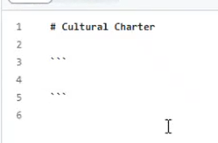

Once this is complete, write in lower-case next to the 3 back ticks on line three **“slideshow”.** Next, write the full file path to the document on line four, for example:

**“docs/strategy/cultural-charter/Slide1.SVG”**

You must then copy the above for how ever many slides there are in the presentation (in this case there are 9 slides). See “[Kitchen Sink](https://cps-innovation.github.io/digital-sop/activities/documentation/kitchen-sink/#slideshows)” for further guidance.

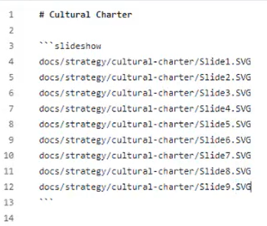

***\*\*It is important to ensure the full path to the document is accurate with capital letters etc. It is also important to ensure you DO NOT include* spaces in between each word for the file path*\*\****

***If you wish to hide the navigation menu, you can***

Once you have done this, click the “**Commit changes”** box on the top right of the screen.



Then complete the **“Commit message”** box with what specific action you took whilst editing the page (this is extremely important as this is a summary for an audit trail entry), for example:

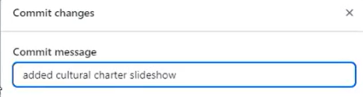

Ensure the tick box is selected to the branch you created. For example: **“Commit directly to the adding-ur-landing-page-branch**”.



 Then you can click “**Commit changes”**.

A screenshot of the "Commit changes" button.

Once you have committed changes, click the arrow on the **“Add file”** button on the top right of the screen and select **“Upload files”.**

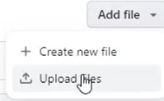

Go to your documents (where the document you wish to embed is saved) and rename the folder to the name you entered on the GitHub page, for example:

**\*NOTE\*** *Do not include spaces in the folder name.*

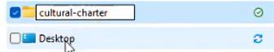

You should then be able to drag and drop the folder from your documents to the upload file section on GitHub:

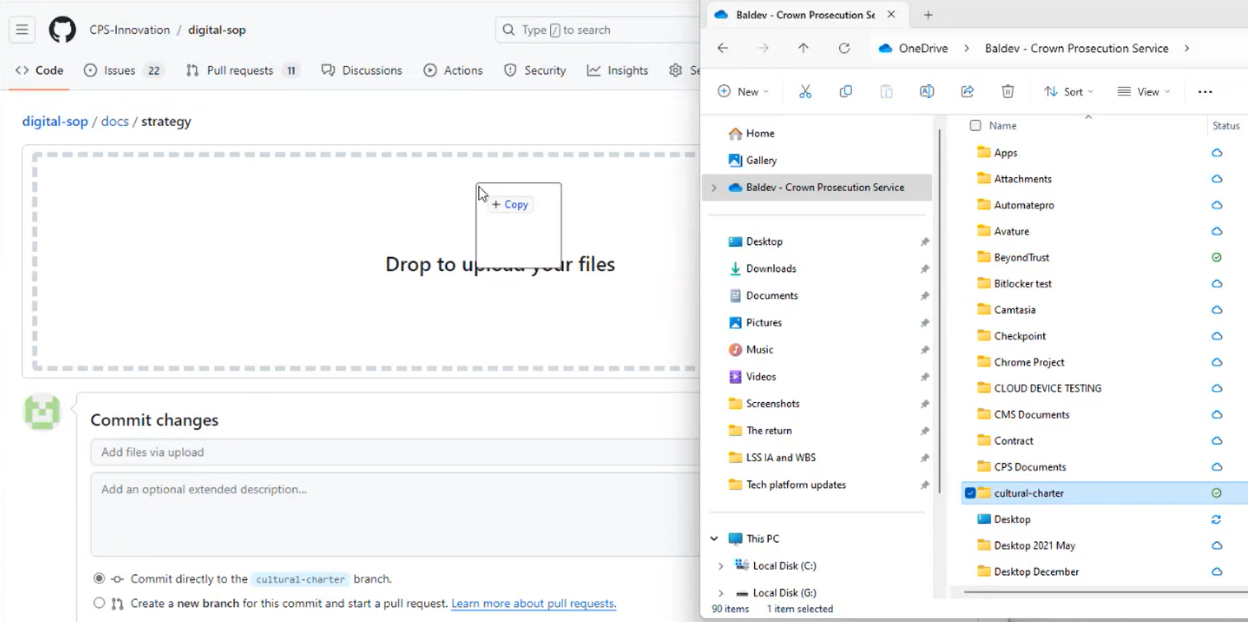

Alternatively, you can select the **“Or choose your files”** option on the GitHub page and search for the folder this way.

Once the files are uploaded, scroll down to the bottom of the page, and complete the **“Commit changes”** box to confirm what you have done, for example:

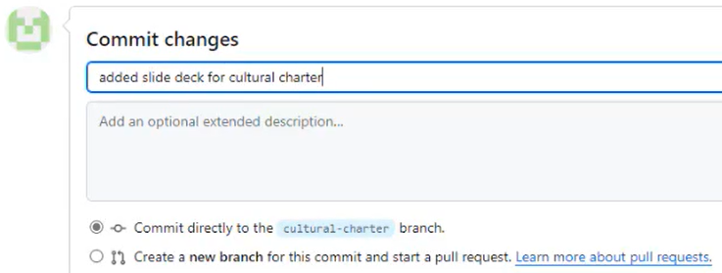

Then click the **“Commit changes”** box to confirm.

A screenshot of the "Commit changes" button.

Once this has uploaded, you should go into the **“docs”** folder and the correct subfolder to ensure the upload was successful.

Once you are happy the document/s are uploaded, go to **“Pull requests”** at the top of the page.



Click the box that you were working on and wait for the orange circle to turn into a green tick, for example:

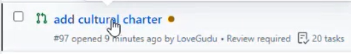

Once this has tuned into a tick, scroll to the bottom of the page, and click the **“Squash and merge”** button. Then click **“Confirm squash and merge”**.

A screenshot of the "Confirm squash and merge" button.A screenshot of the "Squash and merge" button. -

Once this has been complete. Scroll to the top of the page and click the **“Actions”** button on the top of the screen and wait for the orange circle in the **“publish”** box to turn green.

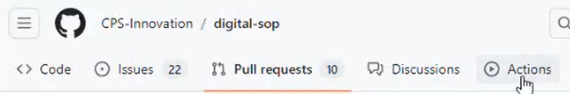

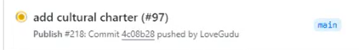

Once this has completed, you can go back to the website to check your upload was successful and check the formatting of the document you embedded is correct.

# Admins/Owners

Granting new users “Write” permission**:**

**\*Please note there are 28 licences available for GitHub in total across the CPS, it is important to ensure Owners are informed when users leave so we can grant users licences when needed. \***

Once a user has submitted their username to the “Owner” and their request to join the group has been approved, administrators are able to grant users their “write” permissions and/or add them as “Admins”

To do this, click “digital-sop”

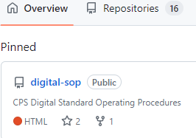

Then click the “Settings” button on the panel at the top of the page.

Screenshot of panel with an arrow pointing to the "Settings" button. 

Then click the “Collaborators and teams” option on the left navigation panel on the left of the page.

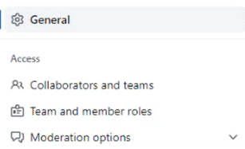

You can then select the “Add people” button.

A screenshot of the "Manage Access" page with an arrow pointing to the "Add people" button. 

This will then bring up a pop-up box, enter the username of the person you wish to grant “write” permission to and click “Select a member above”.

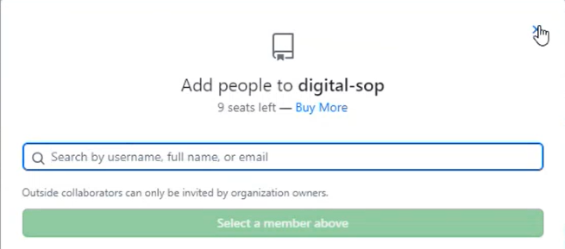

Once you can see their name in the “Manage access” list, click the drop-down box and select “Write” to change their permissions. The user can then edit/update pages.

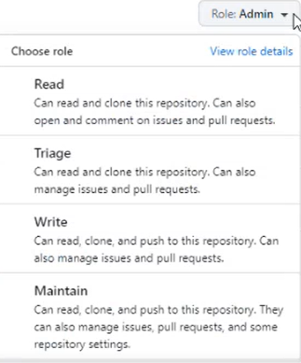

Admins reviewing changes/Pull requests**:**

When a user has created a change to a page and submitted a “Pull request”, they will need to complete the checklist and then select “Reviewers” which will bring a drop-down box where you can select an admin to review your work.

Once you have selected an admin to review your request, they will receive an email saying, “Review this Pull request”.

The admin can the link to the GitHub page on the email they received and then navigate to the “Files Changed” button.



This will then display a “Difference” which is the code that was previously displayed before the user made any changes, and the code that is displayed after the user made changes (Which will be displayed in green). The admin will then need to click “Review changes” in the top right corner of the page.

This will then display a pop-up box with a few different options you can select.

The admin can then look at the changes made by the user and decide whether the changes can be approved. The admin must leave a comment in the “Write” box confirming the changes are ok to be made then change the tick box to “Approve”, then “Submit review”.

Alternatively, if the admin thinks further changes should be made, they can click out of the pop-up box and select the “plus” icon next to the line number which contains the edits that need to be changed.

This will then bring up another pop-up box which allows you to write a comment about that line of content.

You can then say comments such as “This wording is incorrect; you need to change …”. Once you have left your comment, you can click “Start a review”.

The admin can then go back to the “Review changes” box in the top right of the page and leave a further comment such as “There are a couple of changes to get sorted …”. You can then keep the “Comment” tick box selected and press “Submit Review”. This allows the user to make any suggested changes.

Inviting a new user to the CPS Digital and Innovation organisation:

When a user wants to join the CPS Digital and Innovation organisation, they will automatically be part of the Azure Directory “EUC SG GitHub Innovation” group.

When a user requests to join the CPS Digital and Innovation page and you have completed the invite process, users will receive an email stating they have been invited to the group, for example:

Useful links

|  |  |
| --- | --- |
| GitHub Home Page | [Join GitHub · GitHub](https://github.com/signup?ref_cta=Sign+up&ref_loc=header+logged+out&ref_page=%2F%3Corg-login%3E&source=header) |
| GitHub CPS Innovation page | <https://github.com/cps-innovation> |
| GitHub Kitchen Sink | [digital-sop/docs/activities/documentation/kitchen-sink.md at 524927091af4e83eed367e86a9192723d5e67df9 · CPS-Innovation/digital-sop (github.com)](https://github.com/CPS-Innovation/digital-sop/blob/524927091af4e83eed367e86a9192723d5e67df9/docs/activities/documentation/kitchen-sink.md#L1) |
| Digital Standard Operating Procedures (SOP) Home Page | [Home - Digital Standard Operating Procedures (cps-innovation.github.io)](https://cps-innovation.github.io/digital-sop/) |

GitHub Home Page - [Join GitHub · GitHub](https://github.com/signup?ref_cta=Sign+up&ref_loc=header+logged+out&ref_page=%2F%3Corg-login%3E&source=header)

GitHub CPS Innovation page - <https://github.com/cps-innovation>

GitHub Kitchen Sink - [digital-sop/docs/activities/documentation/kitchen-sink.md at 524927091af4e83eed367e86a9192723d5e67df9 · CPS-Innovation/digital-sop (github.com)](https://github.com/CPS-Innovation/digital-sop/blob/524927091af4e83eed367e86a9192723d5e67df9/docs/activities/documentation/kitchen-sink.md#L1)

Digital Standard Operating Procedures (SOP) Home Page - [Home - Digital Standard Operating Procedures (cps-innovation.github.io)](https://cps-innovation.github.io/digital-sop/)